First Fleet Research Assignment
Part 1 - The Journey
You will be given a blank map of the world. Use books and/or some of the sources on the resource centre weebly site to find out some information about the route that the first fleet took from England to Australia. Answer these questions:
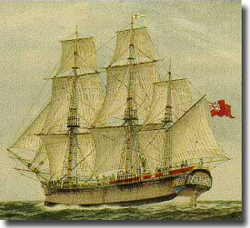
- Where did the fleet stop over on the way?
- Why did it stop at these places?
- How long did they stop there?
- On your map draw the route that was taken and label all relevant places.
- Include some dates on your map route.

