The Convicts – Worksheet 1 Name
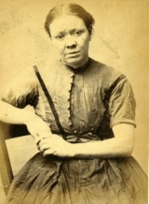
Find out the meaning of each job and write it in the table alongside the skills needed for that job.
Brickmaker Carpenter Milliner Labourer Charwoman
Farmer Chimney Sweep Caulker Weaver Hawker

Job | Skills
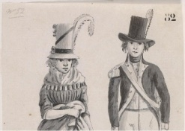
I build and fix the wooden parts of houses and other buildings
 | I weave the material that is used to make clothes
 | I am skilled to work with animals and plants
 | I walk around the streets selling goods to people in their houses
 | I make things waterproof by filling the spaces between planks or boards. I work mainly with boats and ships.
 | I am young and small. I climb down chimneys to clean them out.
 | I am a male. I have no training but I am strong and hard working. I like to work outside.
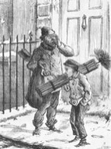
I am a female and I do odd jobs of housework like cleaning, dusting, polishing, washing and making beds.
 | I am a girl who makes and sells hats for women.
 | I dig up clay and make it into blocks for building.
My 3 choices are:
- because

- because

- because

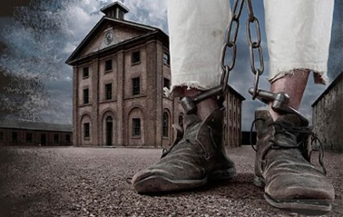

The Convicts – Worksheet 2 Name
Convict’s Name | Occupation | Ship | Crime | Sentence | Leaving Age
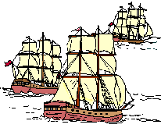
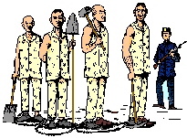

The Convicts – Worksheet 3 Name
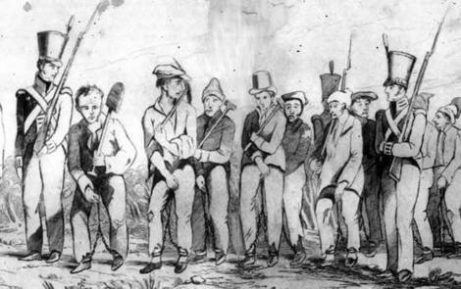
You now have to select your final three convicts to be pardoned as you have decided that they are the best for the job of assisting the new colony. The Convicts you choose need skills in either:
- Helping to improve building in the colony
- Helping to run Government House
- Helping to improve farms and gardens

Convict’s Name | Occupation | Reasons

